**AI in Smart Cities**

**INT-404**

**TOPIC: [ P-02 ]**

Improving waste management through real-time

monitoring and data analysis.

**SUBMITTED BY:**

|  |  |  |
| --- | --- | --- |
| **NAME** | **ROLL NO** | **REG NO** |
| Prince kumar | K21WYA02 | 12112403 |
| Amit gupta | K21WYA27 | 12112447 |
| Cheeraboina  jayaraju | K21WYB52 | 12109258 |

**SUBMITTED TO:**

Dr.Prateek Agrawal

**Introduction**

As the world's population continues to grow and urbanization becomes more prevalent, the concept of smart cities is becoming increasingly important. Smart cities utilize advanced technologies, such as artificial intelligence (AI), to improve the quality of life for residents and increase the efficiency of city services. One critical area where smart city technologies can make a significant impact is in waste management.

Waste management is a significant challenge for many cities, with growing populations and consumption leading to increased volumes of waste. Inefficient waste management practices can have significant negative impacts on the environment, public health, and the economy. However, by leveraging real-time monitoring and data analysis through AI, cities can optimize their waste management processes, reduce waste generation, and improve sustainability.

Using this waste classification model we can scan the waste and put the waste in an appropriate model by doing this we can reduce waste and recycling rates can be increased and we can manage the waste more efficiently using this model.

**SCOPE OF THE PROJECT**

Artificial intelligence (AI) has the potential to improve waste management in smart cities through real-time monitoring and data analysis.

Existing waste management systems in many cities are often ineffective and cause environmental pollution, health hazards and economic losses. Integrating AI-driven waste management into smart cities can help improve waste management, transportation and disposal, leading to cost savings and environmental improvements.

Real-time monitoring of waste generation and collection is essential for effective waste management. AI-powered sensors can be placed in bins and trucks to collect data on the fill levels and locations of the garbage, as well as how much garbage is collected.This information can be used to improve waste collection methods, predict waste generation patterns, and identify areas that require more or less waste.

Data analytic is another important aspect of AI-driven waste management. By analyzing data collected from sensors, AI algorithms can identify patterns and trends such as when waste is high, different types of waste generated, and areas with the most waste. This information can be used to create waste reduction plans, improve recycling services and optimize disposal processes. AI-driven waste management can also help reduce the environmental impact of waste disposal by identifying opportunities for waste recycling, composting and electricity generation.

Overall, AI-driven waste management systems offer significant opportunities to improve waste management in smart cities. By enabling real-time monitoring and analysis of data, these systems can help improve waste collection and disposal, reduce pollution and health hazards, and support sustainable waste management.

**RELATED WORK**

We build a waste classification model using python and some python modules.we olso used a website teachable machine which trained our module on different images of the datasets.we install some python packages/library and imported it like : TensorFlow,keras,opencv,tkinter.using this model you can classify the type of waste by giving a image as an input.

**Objectives**

The objectives of implementing AI-powered waste management systems in smart cities are as follows:

* Enhance recycling and composting: AI algorithms can analyze waste composition data to identify recyclable materials and develop strategies to maximize their recovery, leading to a reduction in waste sent to landfills and an increase in the use of sustainable waste management practices such as recycling and composting.
* Increase public awareness: By analyzing data on waste generation and disposal, AI-powered waste management systems can help develop targeted waste reduction campaigns and increase public awareness about the environmental impact of waste, leading to more responsible waste management practices.
* To accurately categorize different types of waste materials based on their physical and chemical properties.
* Help reduce waste going to landfills and reduce environmental pollution.
* Garbage collection and transport efficiency has been improved.
* Optimize waste management and reduce operating costs.
* Make , use and recycle waste.
* Promote the circular economy and reduce resource consumption.
* Promote sustainable behavior among residents and businesses.
* supports the city's sustainability goals and reduces the city's carbon footprint.
* Prevent the release of hazardous substances into the environment.
* Promote public health and safety by reducing hazardous waste.

**Proposed methodology**

We can identify the kind of waste it is using this waste classification model. this model, which we trained to operate on a specific datasets, identifies the type of waste. we used python and some module name opencv, tkinter, and a google website teachable machine which trains our model on a data set containing various images and with the help of it we can recognize the type of waste and after recognizing the type of waste we can easily put it into its appropriate bin so that recycling speed can be increased and waste can be managed in a smart city.

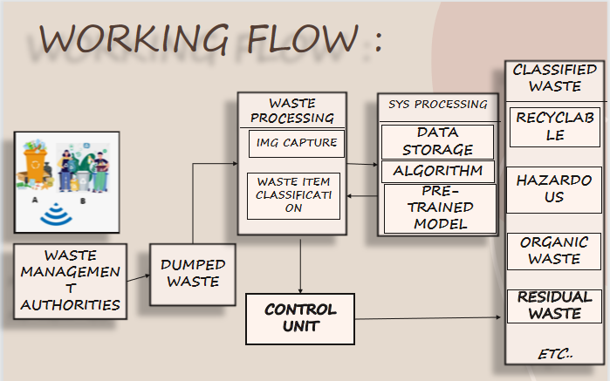

IMG-1

Block/sequence diagram

**Complete code of working project**

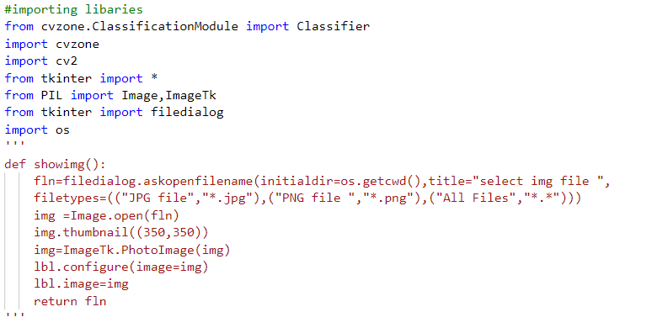

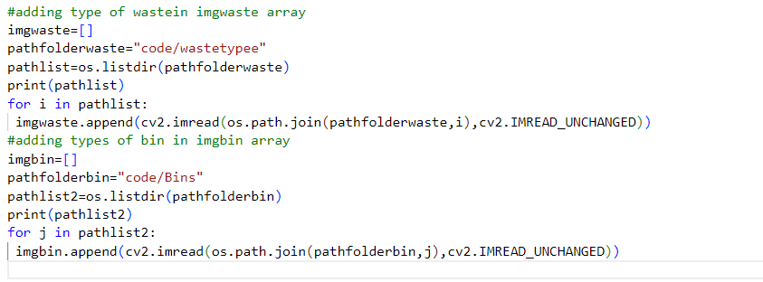

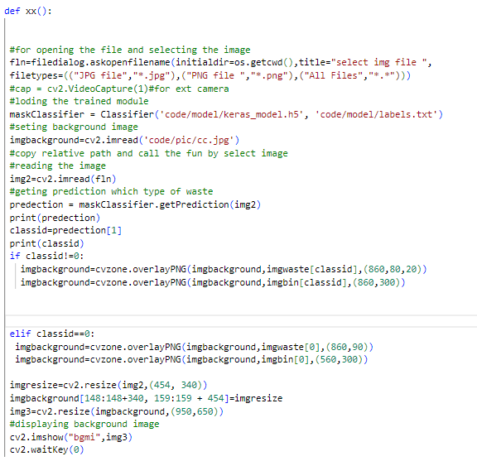

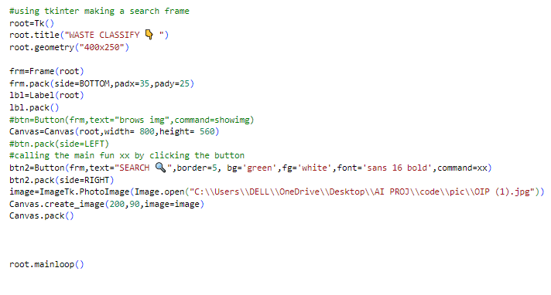

AFTER RUNNING THE CODE:



IMG-2

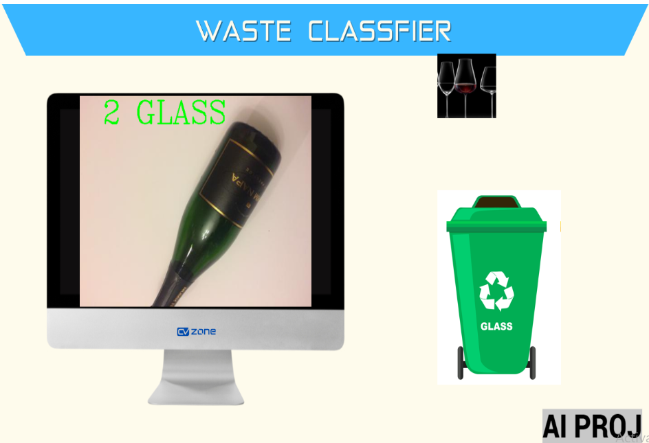

IMG-3

**Result analysis**

The above project is a waste classification model that uses AI to classify 7 different type of waste .the model was trained on a datasets consisting 2500 different type of waste images .As much as you trained your model on datasets better and more efficient it become.In IMG-3 I selected a glass image from the data-set and it predicting the type of waste correctly and it is getting the appropriate bin .

From the data set that i trained this module it is giving around 95% accurate results. Its accuracy increased as much as you trained it on different datasets and different classes.

**Conclusion**

To conclude, the implementation of artificial intelligence (AI) in smart city waste classification models offers great promise for improving waste management practices. By automating the waste sorting process, these models can significantly enhance waste sorting accuracy, minimize contamination rates, and optimize waste management operations.

Overall, AI-driven waste management systems offer significant opportunities to improve waste management in smart cities. By enabling real-time monitoring and analysis of data, these systems can help improve waste collection and disposal, reduce pollution and health hazards, and support sustainable waste management.

**References**

1. [Intelligent Waste Classification System Using Deep Learning Convolutional Neural Network - ScienceDirect](https://www.sciencedirect.com/science/article/pii/S2351978919307231)
2. Python Programming | [Deep Learning basics with Python, TensorFlow and Keras](https://pythonprogramming.net/introduction-deep-learning-python-tensorflow-keras/" \t "https://medium.com/geekculture/_blank) by sentdex